

Packet Tracer - Configuring DHCP Using DHCP Server

## Topology

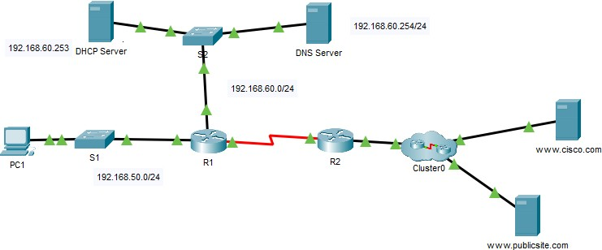

**Addressing Table**

|  |  |  |  |  |
| --- | --- | --- | --- | --- |
| **Device** | **Interface** | **IPv4 Address** | **Subnet Mask** | **Default Gateway** |
| R1 | G0/0 | 192.168.50.1 | 255.255.255.0 | N/A |
| S0/0/0 | 10.3.3.1 | 255.255.255.252 | N/A |
| R2 | G0/0 | 192.168.20.1 | 255.255.255.0 | N/A |
| G0/1 | DHCP Assigned | DHCP Assigned | N/A |
| S0/0/0 | 10.3.3.2 | 255.255.255.252 | N/A |
| PC1 | NIC | DHCP Assigned | DHCP Assigned | DHCP Assigned |
| DNS Server | NIC | 192.168.60.254 | 255.255.255.0 | 192.168.60.1 |
| DHCP Server | NIC | 192.168.60.253 | 255.255.255.0 | 192.168.60.1 |

**Objectives**

#### Part 1: Configure a Router as a DHCP Server Part 2: Configure DHCP Relay

**Part 3: Verify DHCP and Connectivity**

**Scenario**

A dedicated DHCP server is scalable and relatively easy to manage. It can be configured to provide DHCP services without the need for a dedicated server. As the network technician for your company, you are tasked with configuring a DHCP server to provide dynamic allocation of addresses to clients on the network. You are also required to configure the edge router as a DHCP client so that it receives an IP address from the ISP network.

# Part 1: Configure the DHCP Server

### Step 1: Exploring the DHCP Server

At first click the DHCP server and then an interface would pop up. Then select the services tab. Here you will find many services but you need to select the second option (DHCP). You will see that the service is off, you need to switch it on.

### Step 2: Create a DHCP pool for R1 LAN

You will find a GUI similar to the figure shown. In the class task you were shown to write commands in router to configure the DHCP pool, however you can configure the DHCP very easily using the GUI provided.

1. Set the pool name as “R1_LAN”
2. Set the default gateway for R1 Lan (find the address from the table given above).
3. Set the IP address of the DNS Server (find the address from the table given above).

### Step 3: Exclude addresses for R1 LAN

Configure **DHCP Server** to exclude the first 10 addresses from the R1. All other addresses should be available in the DHCP address pool.

To do this you need to set the Start IP Address accordingly. For example, to exclude the first 10 addresses of the network 192.168.10.0, the starting address will be 192.168.10.11.

# Part 2: Configure DHCP Relay

### Step 1: Configure R1 as a DHCP relay agent.

The helper address is the IP address of the DHCP server.

**Step 2: Set PC1 to receive IP addressing information from DHCP.**

Open PC1. Go to Ip Configuration and change static to DHCP.

Warning: You may receive DHCP APIPA error the first time. Change it to static and then try changing to DHCP. It should be Successful.

**Part 3: Verify DHCP and Connectivity**

**Step 1: Verify configurations.**

#### Verify that you can browse cisco.com and publicsite.com from PC1 browser.